

**Lab # 05**

**Name : Tahir Hussain Bhutto**

**ID : BIT-23F-009**

**Section : A**

**Subject : Artificial Intelligence**

**Department : BS IT**

Task 01: Write a program that uses a loop to print numbers from 1 to 10.

Code:



Output:

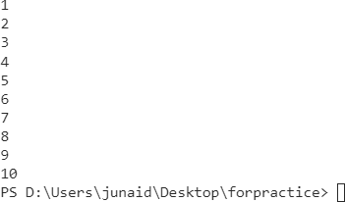

Task 02: Write a function that calculates the sum of all numbers up to a given number using a loop.

Code :

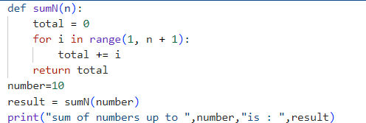

Output:



Task 03: Write code using loops and nested loops to create star

Code :

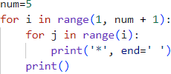

Output:

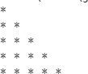

Task 04: Write a function that takes a list of numbers and prints only the even numbers.

Code :

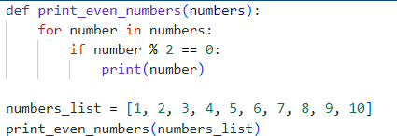

Output:

